AWS VPC Project Documentation
Project Name
Create VPC with Public and Private Subnets, NAT Gateway, Apache, PHP, Tomcat, and VPC Flow Logs

Task 1: Create VPC
Purpose
To create a Virtual Private Cloud (VPC) for hosting AWS resources in an isolated network.
Steps
- Login to AWS Console.
- Go to VPC Dashboard.
- Click Create VPC.
- Select VPC only.
- Enter
Field | Value
Name | project-vpc
IPv4 CIDR | 10.0.0.0/16
IPv6 | None
Tenancy | Default
Click Create VPC.
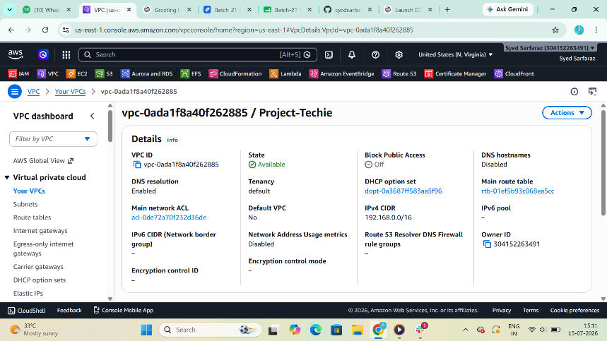

Enable DNS Hostname
Purpose
Allows EC2 instances to receive DNS hostnames.
Steps
Select VPC
Actions
Edit VPC Settings
Enable
- DNS Resolution
- DNS Hostnames
Save.
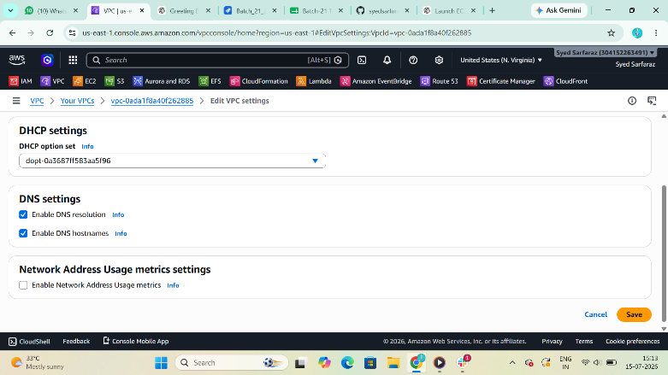

Task 2: Create Public and Private Subnets
Purpose
Create network segments for public and private resources.
Create Public Subnet 1
Name | public-subnet-1
AZ | us-east-1a
CIDR | 10.0.1.0/24
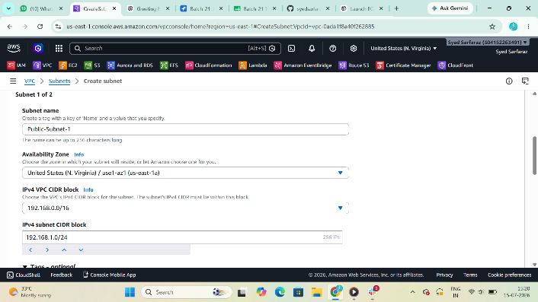

Create Public Subnet 2
Name | public-subnet-2
AZ | us-east-1b
CIDR | 10.0.2.0/24
 | 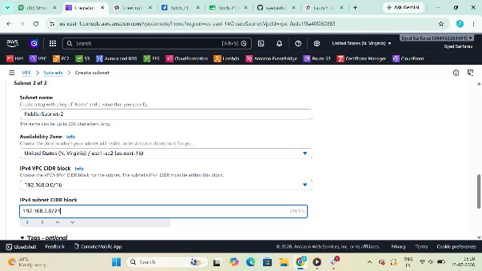

Create Private Subnet 1
Name | private-subnet-2
AZ | us-east-1
CIDR | 10.0.3.0/24

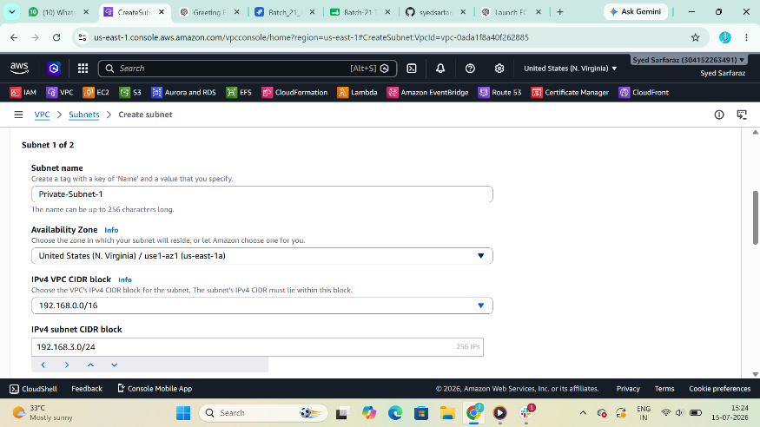

Create Private Subnet 2
Name | private-subnet-2
AZ | us-east-1b
CIDR | 10.0.4.0/24
 | 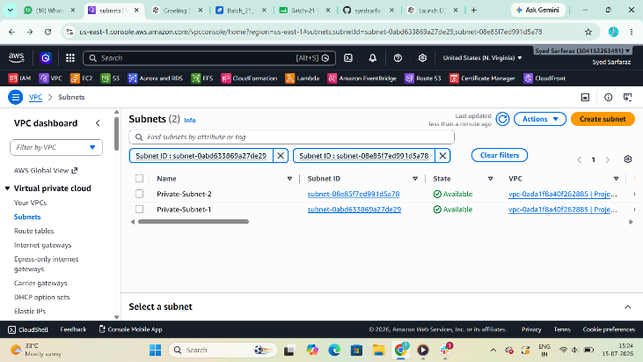

Task 3: Enable Auto Assign Public IP
Purpose
Automatically assign a public IP address to EC2 instances launched in public subnets.
Steps
Select
Public Subnet 1
Actions
Edit Subnet Settings
Enable
Auto Assign Public IPv4
Repeat for Public Subnet 2.
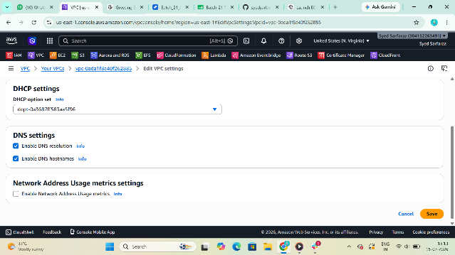

Task 4: Create Internet Gateway
Purpose
Allows internet connectivity for public subnet instances.
Steps
Create Internet Gateway
Name
project-igw
Create
Attach to VPC
project-vpc
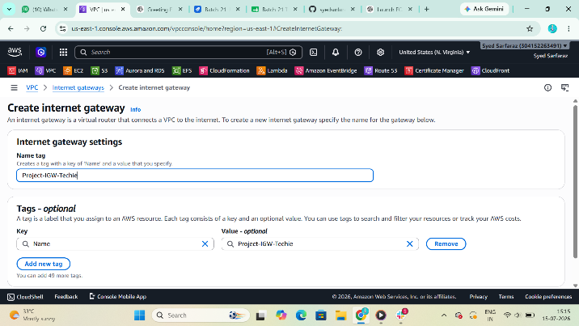
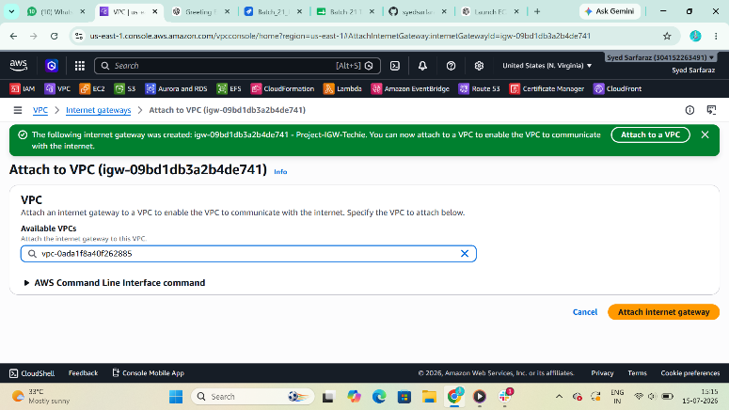

Task 5: Create Route Tables
Public Route Table
Purpose
Provide internet connectivity.
Routes
Destination | Target
10.0.0.0/16 | local
0.0.0.0/0 | Internet Gateway
Associate
- Public Subnet 1
- Public Subnet 2
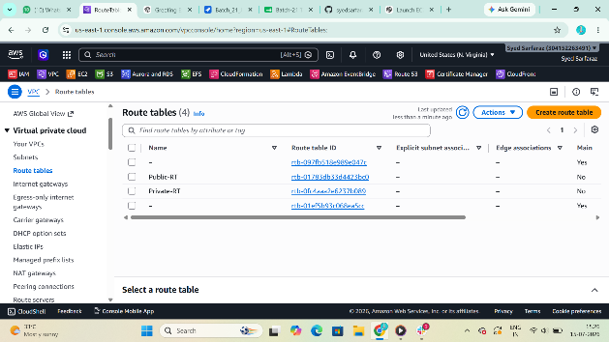
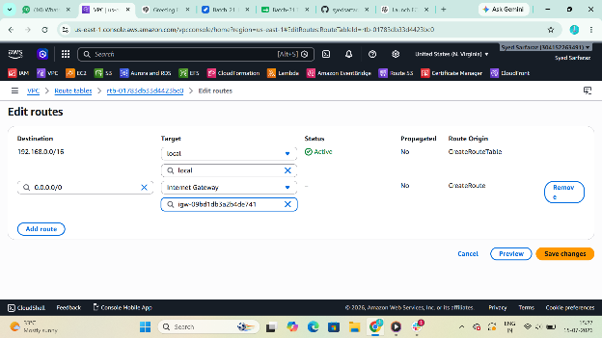

Private Route Table
Purpose
Private instances use NAT Gateway.
Associate
- Private Subnet 1
- Private Subnet 2
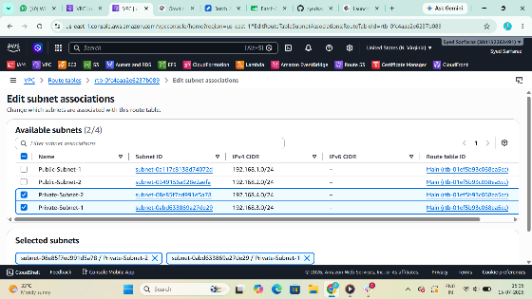

Task 6: Create NAT Gateway
Purpose
Allows private instances to access the internet without exposing them publicly.
Steps
Create NAT Gateway
Field | Value
Name | project-nat
Public Subnet | public-subnet-1
Elastic IP | Allocate New
Create.
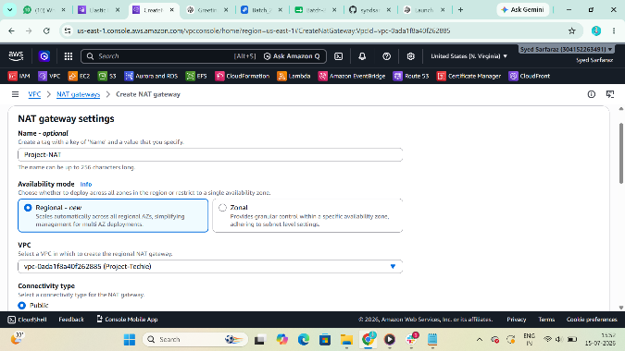

Update Private Route Table
Add Route
Destination
0.0.0.0/0
Target
NAT Gateway
Save.
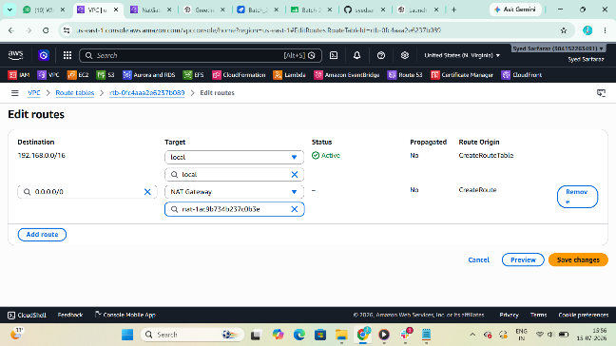

Task 7: Launch Public EC2
Purpose
Host Apache and PHP.
Configuration
Option | Value
AMI | Amazon Linux 2
Instance | t2.micro
Subnet | Public Subnet
Public IP | Enabled
Security Group | HTTP, SSH
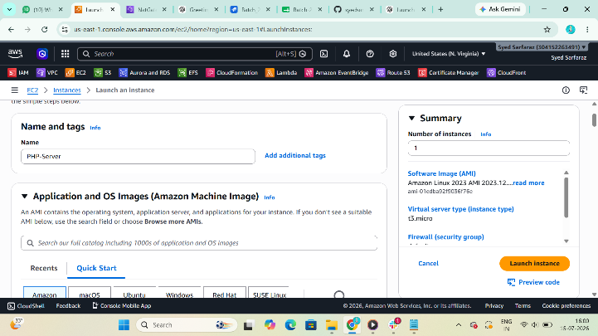
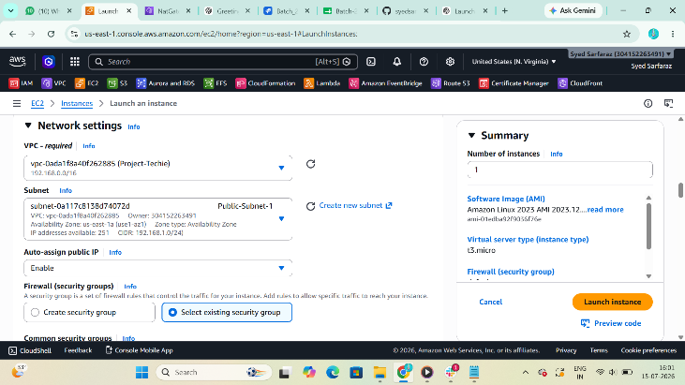
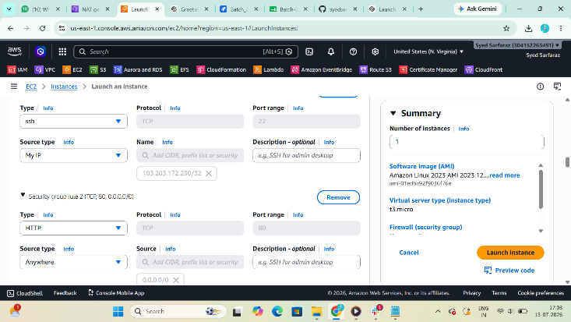

User Data
#!/bin/bash
yum update -y
yum install -y httpd php
systemctl start httpd
systemctl enable httpd
echo "<?php phpinfo(); ?>" > /var/www/html/index.php
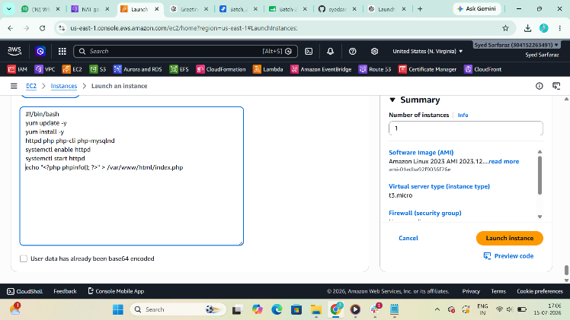

Purpose of User Data
Command | Purpose
yum update | Updates packages
yum install httpd php | Installs Apache and PHP
systemctl start | Starts Apache
systemctl enable | Starts Apache on boot
echo | Creates PHP test page
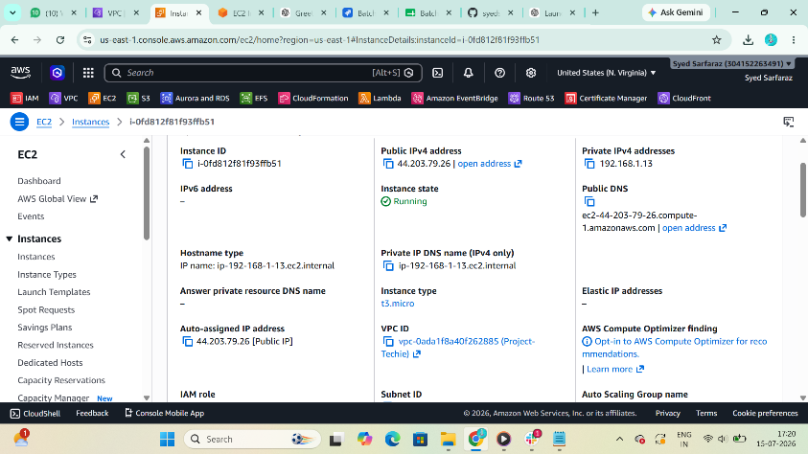

Verification
Browser
http://Public-IP/index.php
Should display PHP Information.

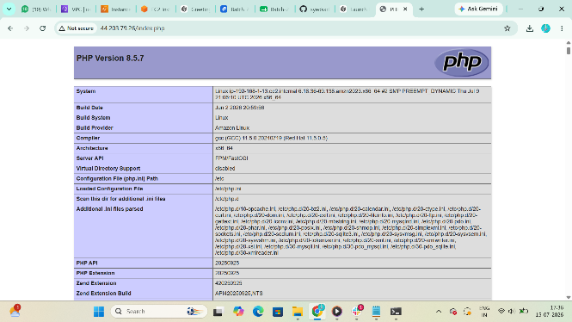

Task 8: Launch Private EC2
Purpose
Host Apache Tomcat.
Configuration
Option | Value
AMI | Amazon Linux 2
Instance | t2.micro
Subnet | Private Subnet
Public IP | Disabled
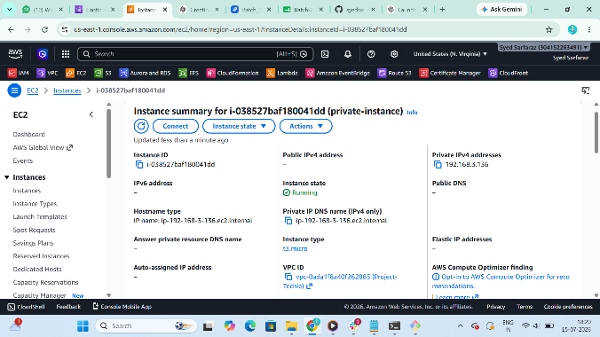

Screenshot Evidence
Private EC2 running.
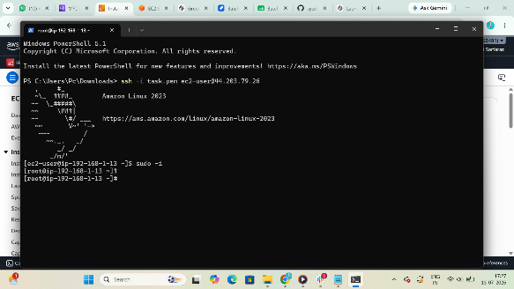

Task 9: Install Java
Purpose
Tomcat requires Java.
Command
sudo yum update -y
Purpose
Updates packages.

sudo yum install java-17-amazon-corretto -y
Purpose
Installs Java.

java -version
Purpose
Verify Java.

Screenshot Evidence
Java version.
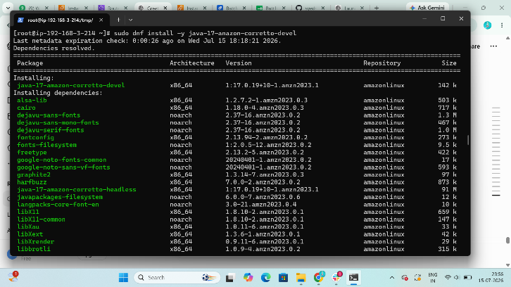

Task 10: Download Apache Tomcat
Purpose
Install Tomcat server.

cd /tmp
Purpose
Move to temporary directory.

wget https://downloads.apache.org/tomcat/tomcat-10/v10.1.48/bin/apache-tomcat-10.1.48.tar.gz
Purpose
Download Tomcat.
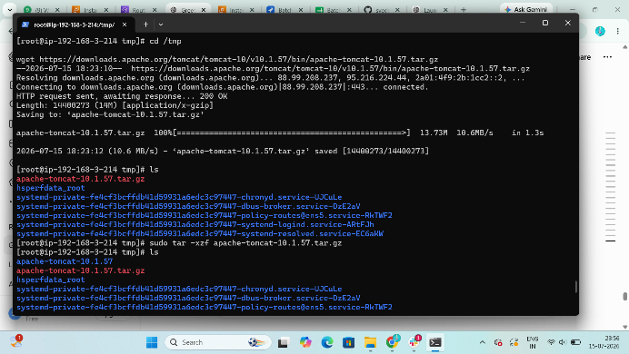

sudo mkdir -p /opt/tomcat
Purpose
Create installation directory.

sudo tar -xzf apache-tomcat-10.1.48.tar.gz -C /opt/tomcat --strip-components=1
Purpose
Extract Tomcat.
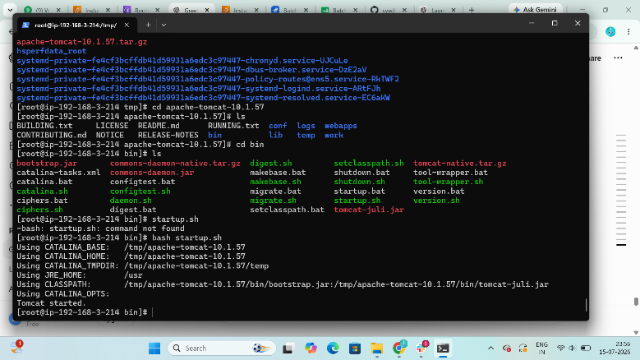

sudo chmod +x /opt/tomcat/bin/*.sh
Purpose
Give execute permission.

sudo /opt/tomcat/bin/startup.sh
Purpose
Start Tomcat.
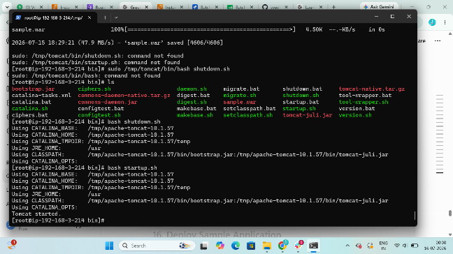

ps -ef | grep tomcat
Purpose
Verify Tomcat process.

Screenshot Evidence
Tomcat running.
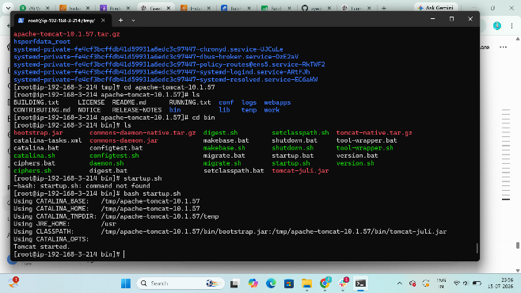

Task 11: Deploy Sample Application
Purpose
Deploy sample web application.
Command
cd /opt/tomcat/webapps
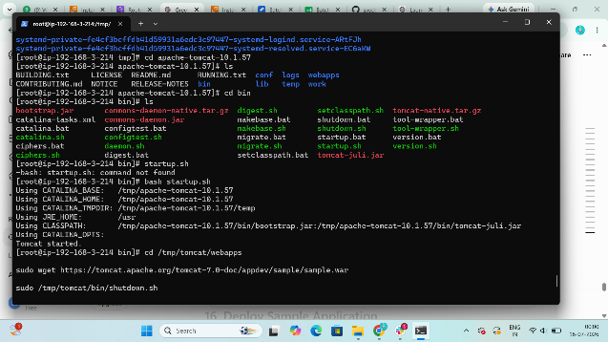

sudo mkdir sample

cd sample

sudo vi index.jsp
Paste
<html>
<body>
<h1>Hello from Apache Tomcat</h1>
</body>
</html>

Restart
sudo /opt/tomcat/bin/shutdown.sh
sudo /opt/tomcat/bin/startup.sh

Verification
http://Private-IP:8080/sample/

Screenshot Evidence
Browser showing
Hello from Apache Tomcat
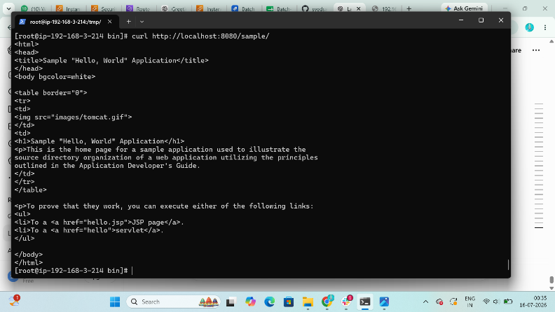

Task 12: Configure VPC Flow Logs
Purpose
Capture network traffic information.
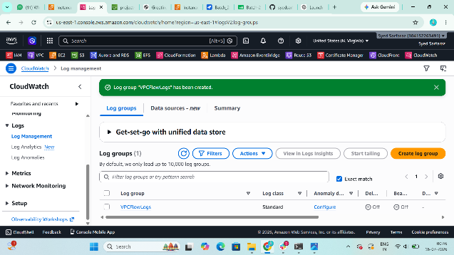

Create S3 Bucket
Example
project-vpc-flowlogs-12345
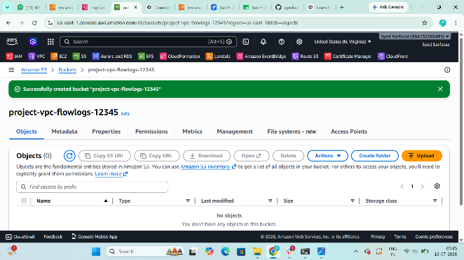

Create Flow Log
Field | Value
Traffic Type | All
Destination | S3
Bucket | project-vpc-flowlogs-12345
Create another Flow Log
Destination
CloudWatch Logs
Create New Log Group
project-flowlogs
IAM Role
Auto Create
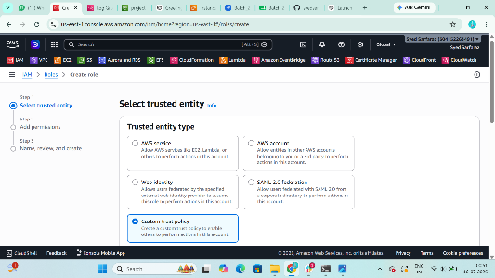
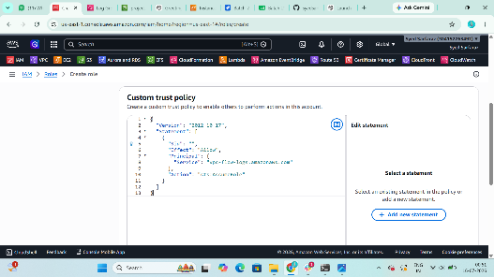

Screenshot Evidence
Flow Log
Status
Active
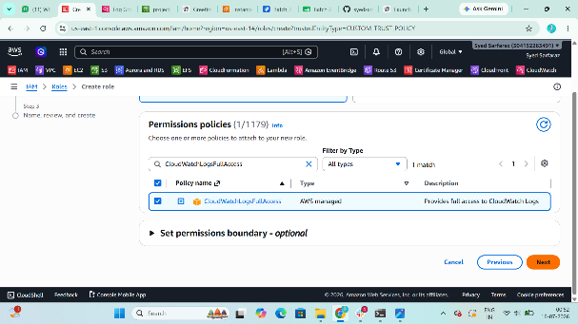

Task 13: Verify Logs
S3
Open bucket
Verify log files.
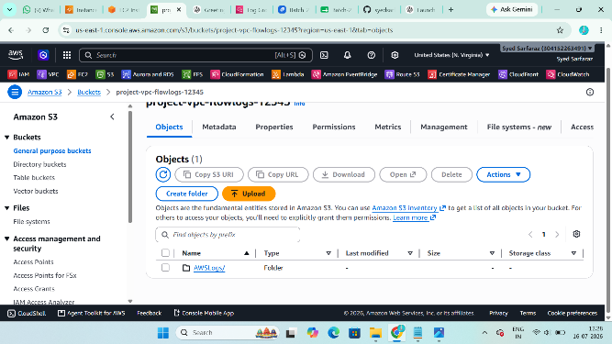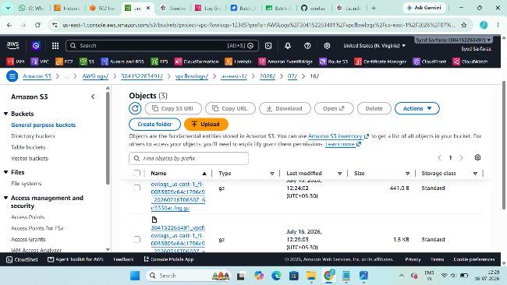

CloudWatch
Open
CloudWatch
Logs
Log Groups
Select
project-flowlogs
Verify log entries.
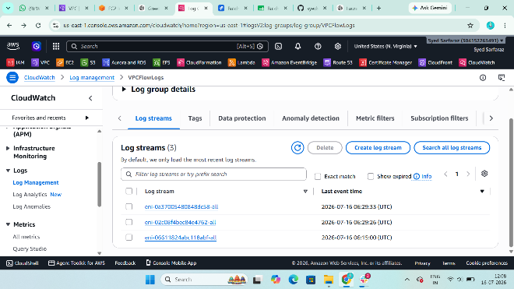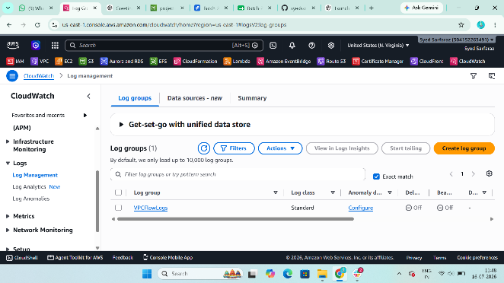
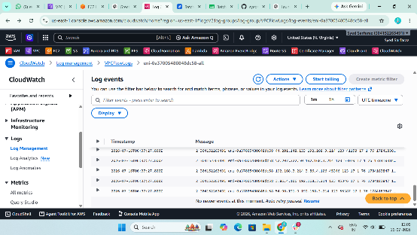

Screenshot Evidence
- S3 Bucket logs
- CloudWatch Log Events
